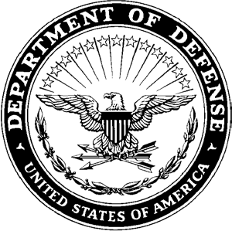**DEPARTMENT OF THE ARMY**

**HEADQUARTERS, AIRBORNE and RANGER TRAINING BRIGADE 10850 SCHNEIDER ROAD**

**FORT MOORE, GEORGIA 31905-5000**

ATSH-RB 16 January 2025

MEMORANDUM FOR Airborne and Ranger Training Brigade

SUBJECT: [INSERT UNIT] Exception to Policy for team composition at the 41st Annual LTG(R) David E. Grange Jr. Best Ranger Competition

1. The [INSERT UNIT] requests an exception to the policy which requires all invited units to send at least one team consisting of entirely enlisted service members and any teams thereafter to have a maximum of one officer per team. The [INSERT UNIT] requests this exception for the following reasons:
   1. [INSERT REASON]
   2. [INSERT REASON]
2. The [INSERT UNIT] would like to request the following team composition for its [INSERT NUMBER OF ALLOCATED TEAMS]
   1. [INSERT TEAM 1 COMPOSTION]
   2. [INSERT TEAM 2 COMPOSTION]
   3. [INSERT TEAM 3 COMPOSTION]
3. The POC for this memorandum is the [INSERT DIV G3 OR CHIEF OF STAFF INFORMATION].

G3/COS NAME

RANK, BRANCH

POSITION

APPROVED/DISAPPROVED PHIL KINIERY

BRIGADIER GENERAL, IN

COMANNDANT